Laboratory report
LAB#3

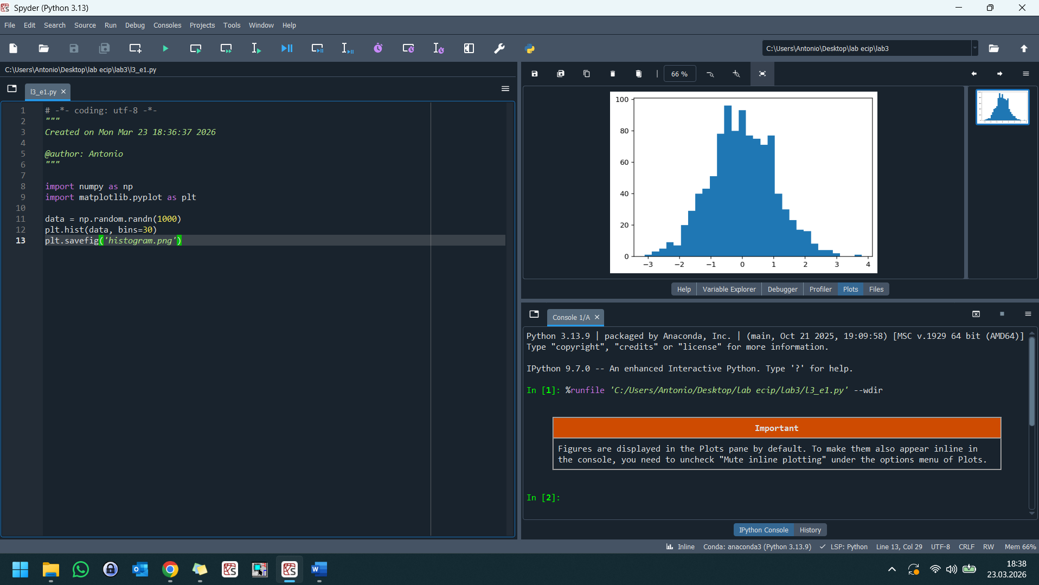
The numbers are pseudorandom, meaning they are generated by a deterministic algorithm that mimics true randomness by following a specific statistical pattern. Because you used randn, the values cluster around a mean of 0 and taper off at the edges, forming a classic Normal Distribution or bell curve.
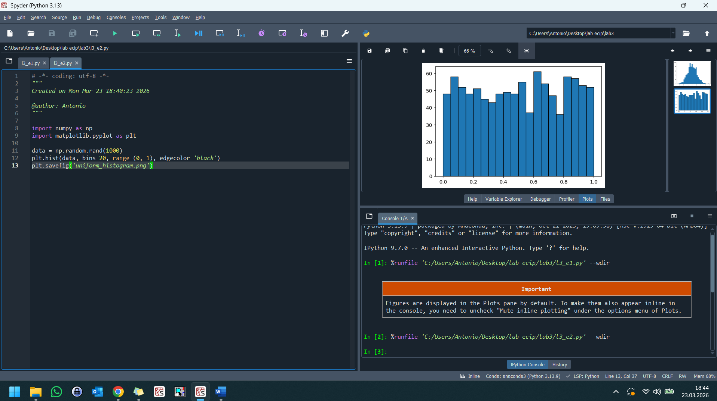
The distribution follows a rectangular shape because every value within the (0, 1) interval has an equal probability of being selected. This reflects a constant probability density, unlike the central clustering seen in a normal distribution.
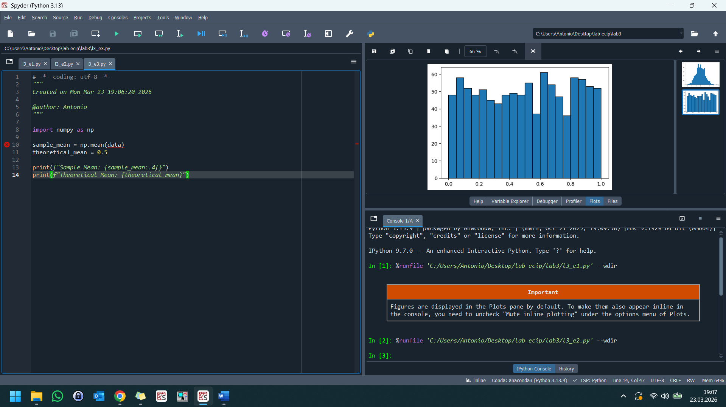
The sample mean of 0.4920 closely aligns with the theoretical mean of 0.5, demonstrating the Law of Large Numbers, which states that the average of results from a large number of trials should be close to the expected value. The slight difference is expected due to sampling variability, which would continue to shrink if the number of generated points were increased further.

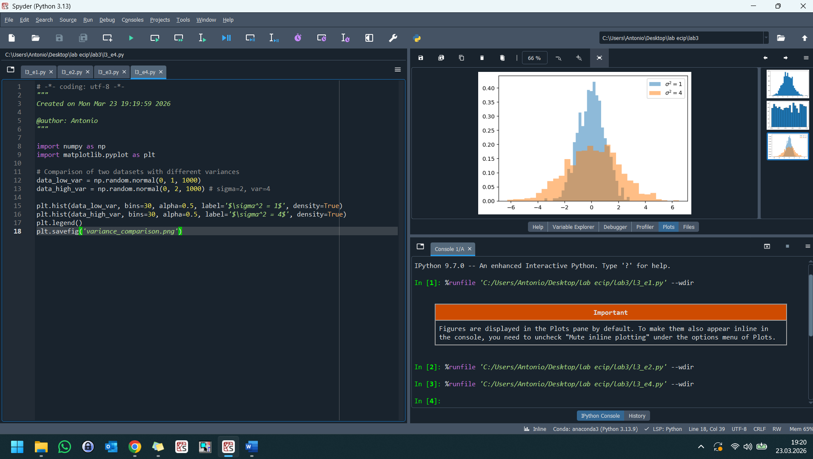
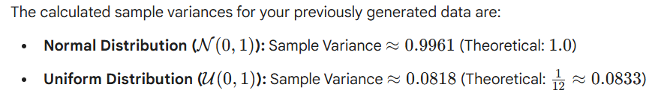

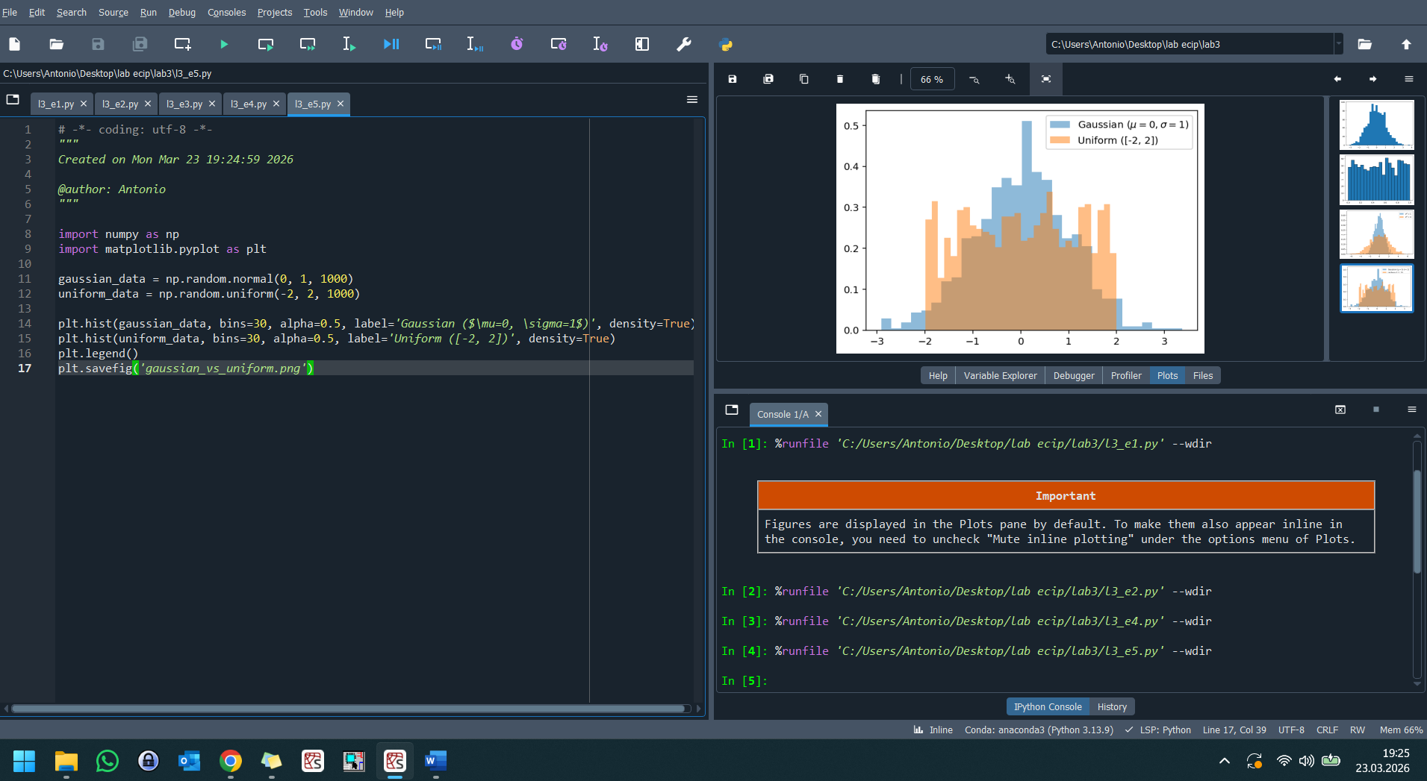
The Gaussian distribution forms a characteristic bell shape, concentrating most values near the mean (0) and showing decreasing density in the "tails." In contrast, the Uniform distribution appears as a rectangular profile because every interval of the same width within its range has an equal probability of containing a value.
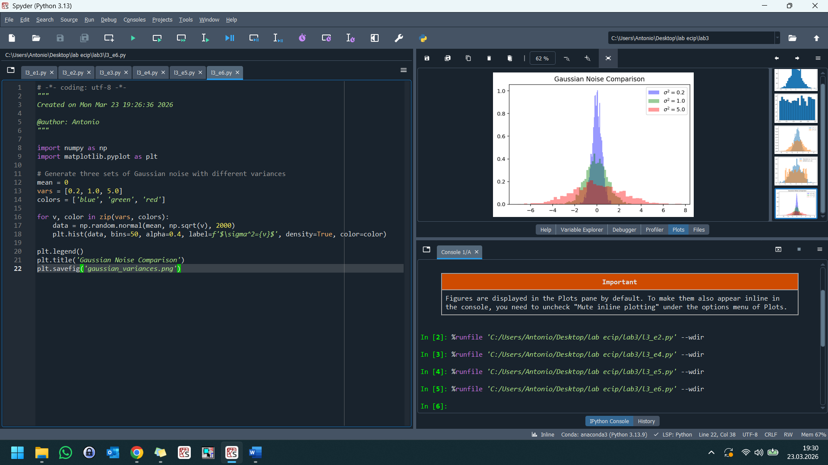
Variance quantifies the uncertainty or "noise" in a dataset: a low variance (sigma^2=0.2) indicates high precision where values are tightly clustered around the mean, while a high variance (sigma^2=5.0) signifies significant uncertainty and a wider range of possible outcomes. In statistical measurement, as variance increases, the probability of any single sample being close to the true mean decreases, representing a less predictable system.
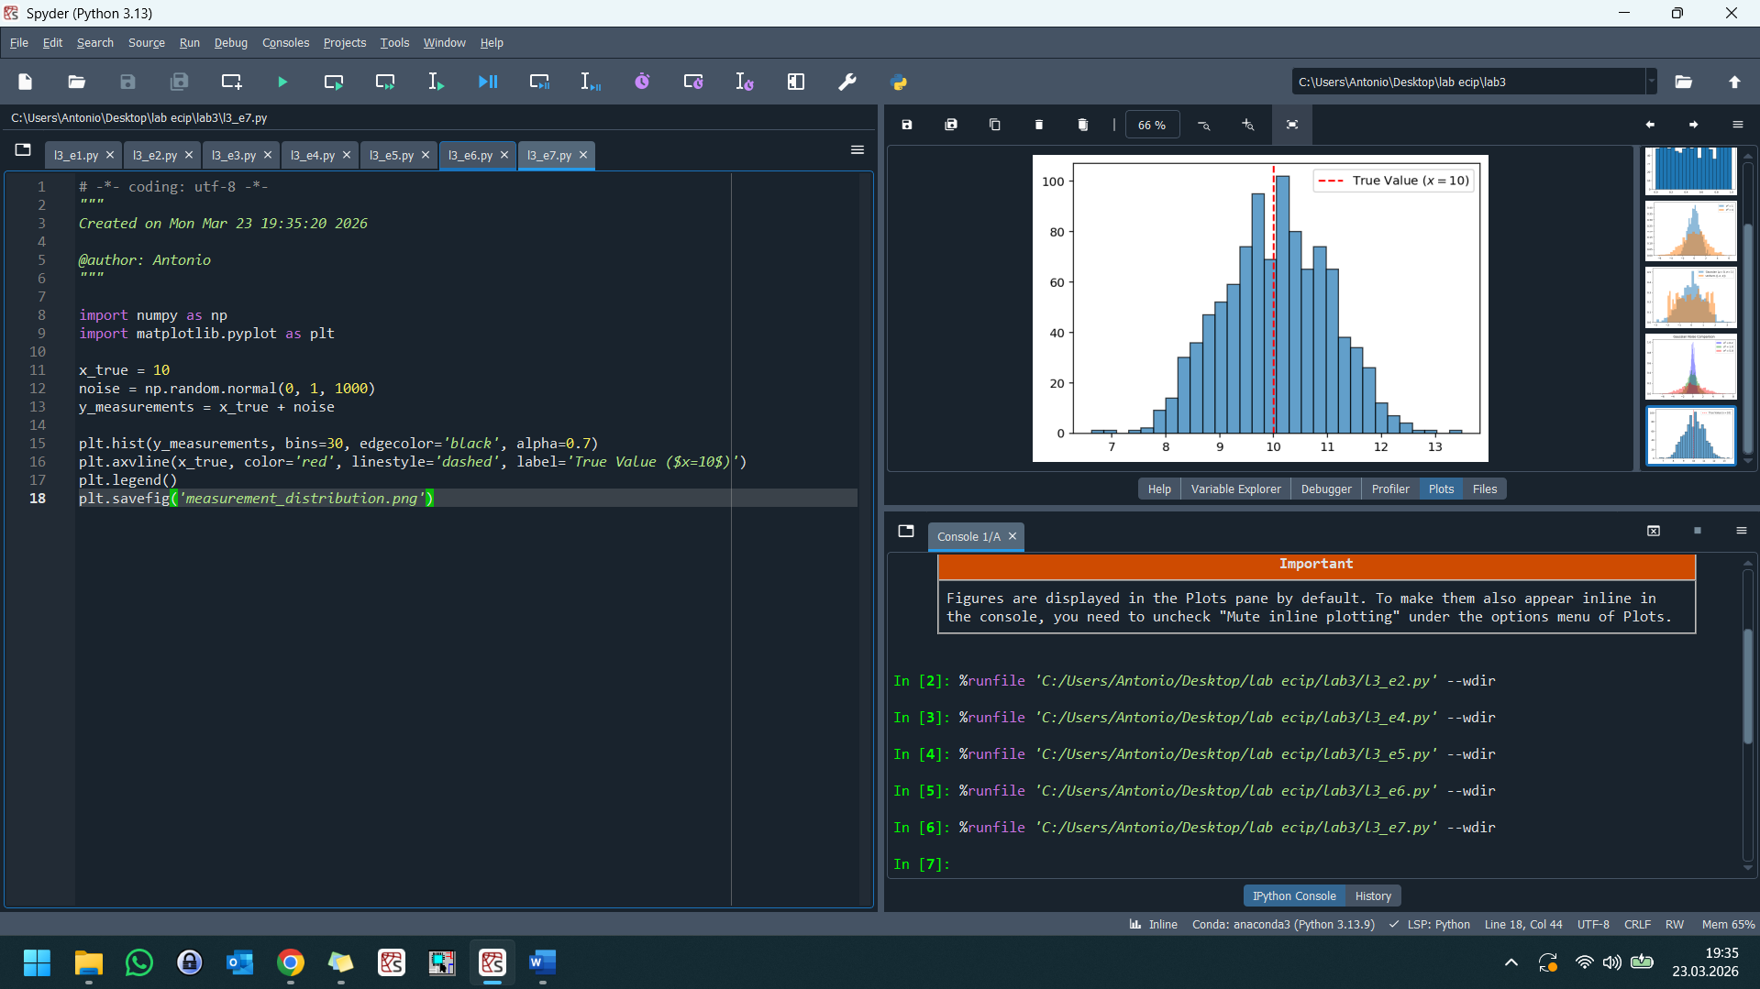
The resulting distribution is centered at the true value x=10, with the Gaussian noise creating a symmetric spread that represents measurement uncertainty. Because the noise is zero-mean, the average of many measurements converges to the true value, illustrating how random errors tend to cancel out in large samples.

l3_e8
The estimate x is significantly more accurate than any single measurement because the random noise terms tend to cancel each other out when averaged. The small remaining estimation error is a result of sampling noise, which follows a distribution centered at zero with a spread that decreases as more measurements are collected.

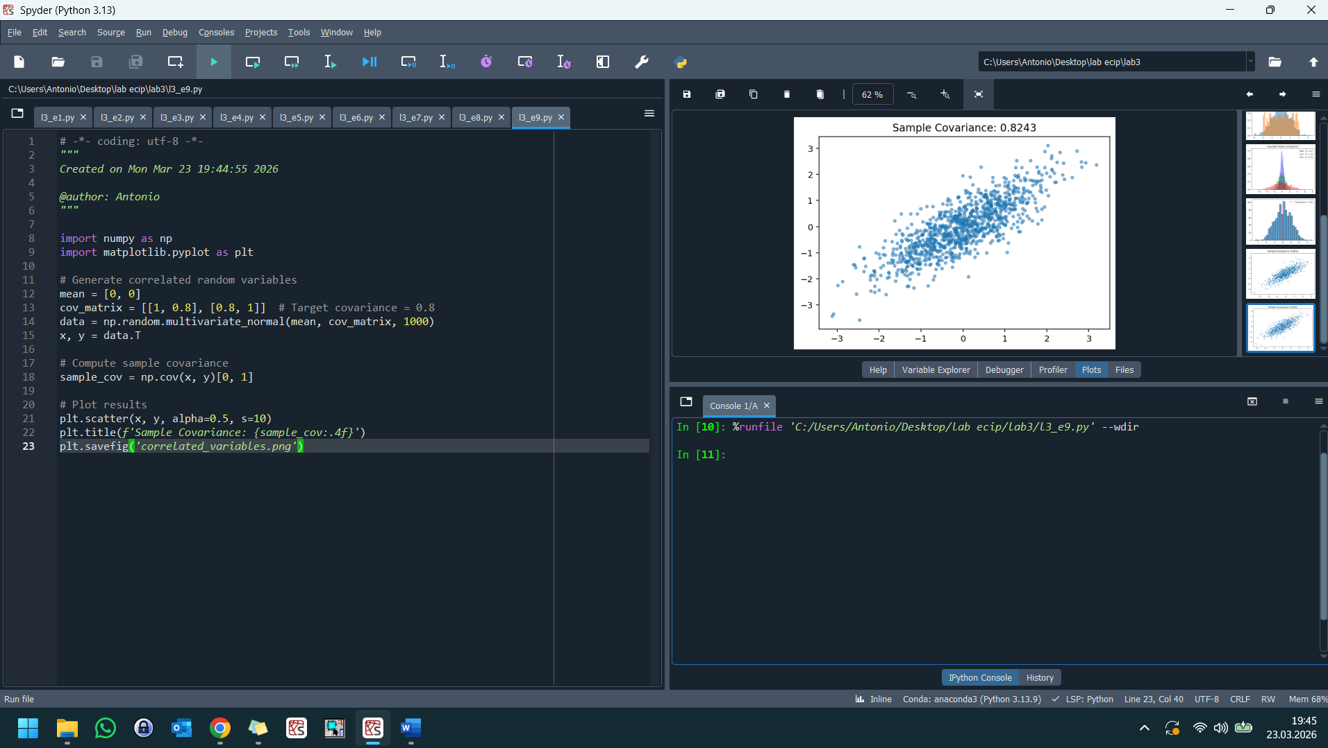
The sample covariance of approx 0.8086 indicates a strong positive linear relationship, where an increase in one variable is typically associated with an increase in the other. This manifests as the elongated "cloud" in the scatter plot, showing how the variables vary together rather than independently.
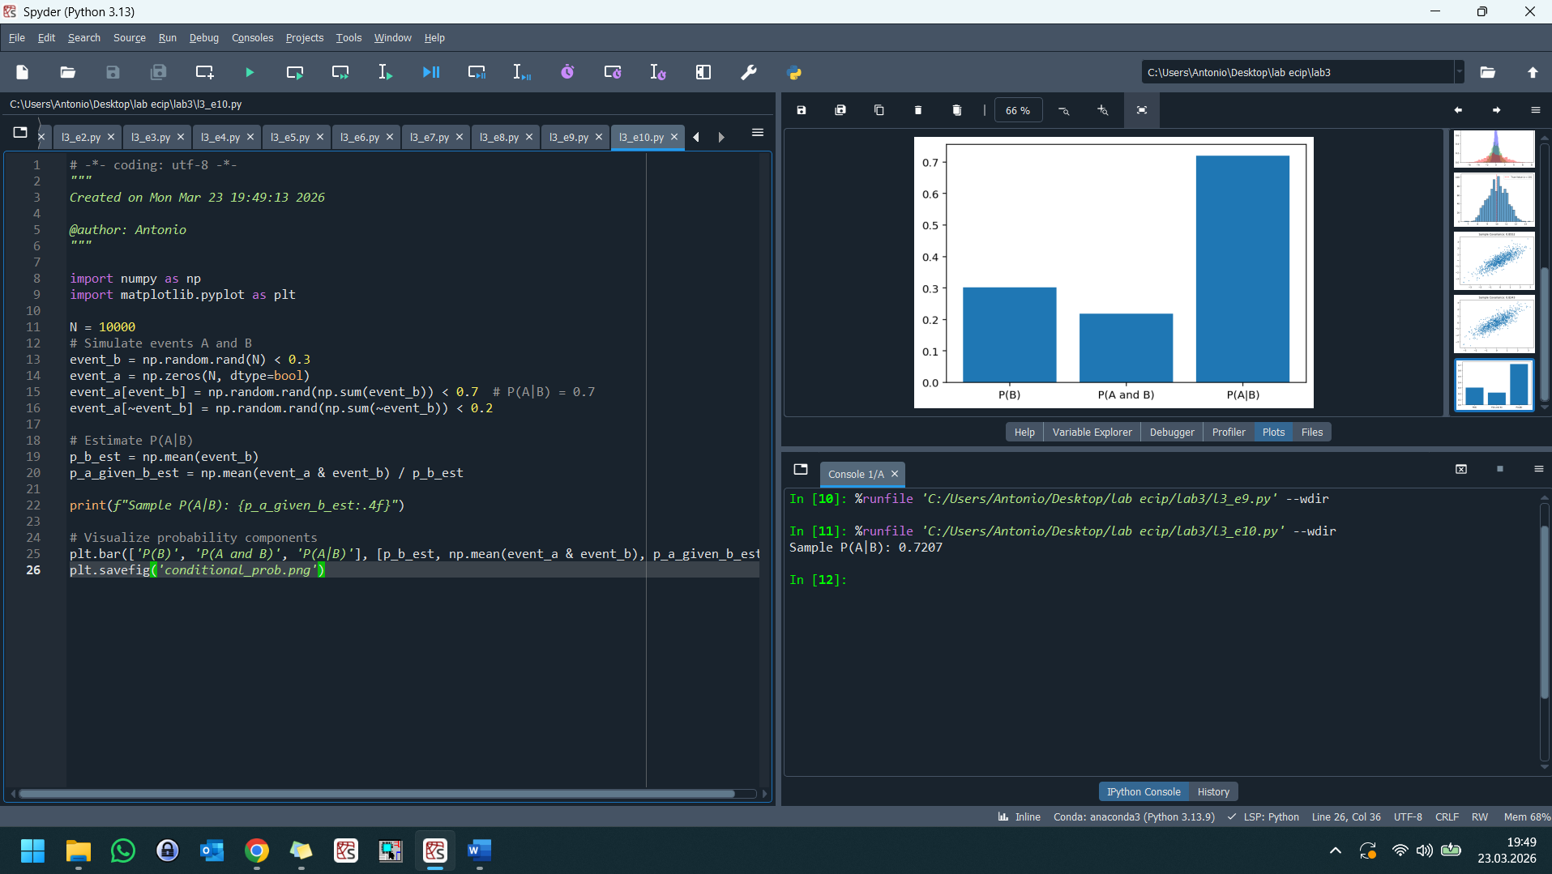
Conditional probability P(A|B) calculates the likelihood of event A occurring given that event B has already happened, effectively restricting our "universe" to only the trials where B is true. It represents the proportion of the subset B that also belongs to A, which is often higher or lower than the overall probability P(A) if the events are dependent.

